38.63: a) The maximum energy available to be deposited in the atom is
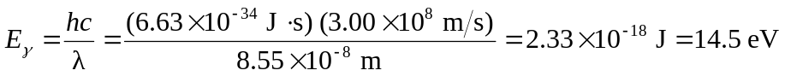
but the inoization energy of hydrogen is 13.6 eV, so the maximum kinetic energy is 14.5 eV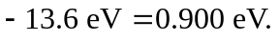
b) If some of the electrons were in the 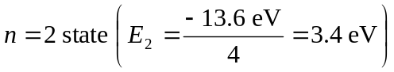, then we would expect a maximum kinetic energy of 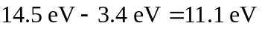, which is exactly 10.2 eV above that measured in part (a), explaining the anomoly.

